Mrs McGuire

C:\Documents and Settings\tmcguire\Local Settings\Temporary Internet Files\Content.IE5\KJM9ITRG\MC900434459[1].wmf 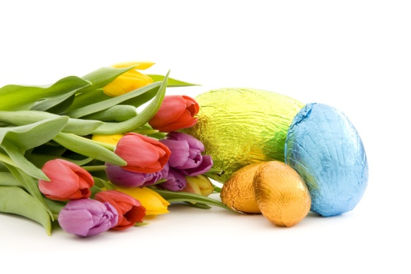

Easter is a holiday in spring. There are Easter Egg Hunts and lots of lilies.

**Spring is a fun time of year with flowers blooming and sun shining.**