Dirty | Exit | Young | Late
Clean | Slow | Poor | OFF
Wet | Sad | Dull | Rich
Full | Fast | Cold | Hot

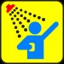
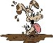
 |  | 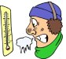
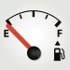 |  | 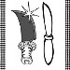
 |  | 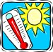
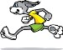
Cut and Paste Opposites
Name:

